Then name of our project

24/6/2016

Our names

* Karl
* Alya
* Abdulhadi Bakhash
* Ehsaan

24/6/2019

**Table of content:**

**Introduction**

**Gathering the Data**

**Preparing the Data**

**Implementing the ML model (NN)**

**Results**

Introduction:

Ecovat is a Pilot project for energy storage, it is a large subterranean buffer tank filled with water, which is used for storing heat and cold for use later on. By storing the sustainably generated energy surplus and using it in times of scarcity, renewable energy is used in an optimal way.

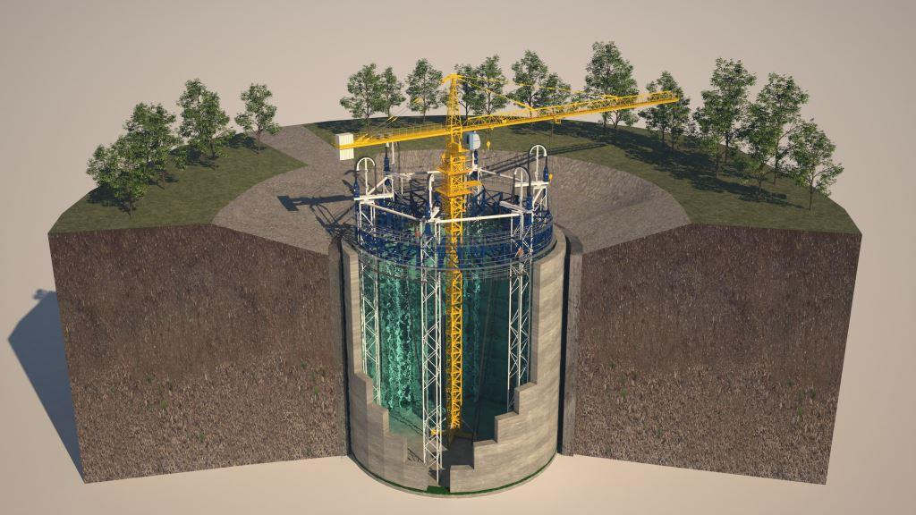

We were supposed to analysis the real dataset from the Ecovat project and build a mathematical model to guarantee the optimal combination of using the surplus generated sustainable energy for heating the tank and heat distribution for the surrounded area, taking in consideration effectiveness and financial aspects.

Unfortunately, we didn't manage to receive the right dataset on time, so we had to search for alternative solutions.

**Gathering the Data**

One of the solutions was the combination of the energy consumption dataset delivered by the HAN and the weather dataset derived from the KNMI web site to build a mathematical model that address the relation between the energy consumption and the different parameters of the weather. and build a production model for the expected energy consumptions for the near future.

From the Energy consumption dataset, we chose the most two columns to be a part of our final dataset:

- WP-W kWh (heat pump)

- CV-W kWh ( central heating boiler)

And from the KNMI data set we chose four parameters to be a part of our input array:

# FH = Hourly average wind speed (in 0.1 hour)

# T = Temperature (in 0.1 degree Celsius) in 1.50 m height during the observation;

# SQ = Duration of the sunshine (in 0.1 hours) per hour section

# RH = Hourly sum of the precipitation (in 0.1 mm) (-1 for <0.05 mm);